**Title: Trends in COVID-19 incidence and its association with meteorological factors in Bangladesh**

**Abstract**

The ongoing COVID-19 contagious disease occurred by SARS-CoV-2 has disrupted global public health, businesses, and economics due to widespread infection, with 513.09 million confirmed cases and 6.23 million deaths in 218 countries as of April 30, 2022. To control the rapid spreading of SARS-CoV-2, it is crucial to determine the potential determinants such as meteorological factors and their role. The goal of this study was to look at how COVID-19 cases and deaths changed over time in Bangladesh using Auto-Regressive Integrated Moving Average with explanatory variables (ARIMAX) , and to find meteorological characteristics that could be impact on these disparities from the beginning of the pandemic in Bangladesh. The required data was collected from Bangladesh from March 8, 2020 for COVID-19 cases and March 17, 2020 for deaths to April 30, 2022 from available online servers. The COVID-19 cases and death related data were collected from the WHO daily COVID-19 situation reports. The meteorological data (rainfall (mm), relative humidity (%), average temperature (°C), sur- face pressure (kPa), dew point (°C) and maximum wind speed (m/s)) were used from NASA's Prediction of Worldwide Energy Resources webpage. We found that average temperature and relative humidity had a significant negative impact on COVID-19 cases (-167.95, 95% confidence interval (CI): -244.06 to -108.17) and (-82.74, 95%CI: -321.70 to -6.23), respectively. However, we found that average temperature relative humidity had a significant positive impact on COVID-19 deaths (2.66, 95%CI: 2.24 to 7.56) and (125, 95%CI: 0.96 to 4.47), respectively. This impact of meteorological factors was almost similar when we included vaccination information in the model. However, the impact of vaccination in both cases and deaths model were significantly negative (for cases: -4.63, 95%CI: -8.65 to -2.92 and for deaths: -0.19, 95%CI: -0.81 to -0.43). To our knowledge, this is the first study in the Bangladesh to identify association between metrological factors with COVID-19 incidence. The study findings will help other researcher and policy makers to take comprehensive actions from considering meteorological parameters to overcome pandemic situation in future.

**Keyword:** Meteorological factors; COVID-19; Mathematical models; Bangladesh; Temperature and Rainfall; SARS-CoV-2

**Introduction:**

In late December 2019, a disease having flu-like symptoms was first discovered in among a few patients in the Wuhan city of China, which was causing acute respiratory syndrome amongst them and upon investigating further, the disease vector has detected as corona virus, which appeared to be a novel strain and termed as the novel severe acute respiratory syndrome coronavirus 2, also known as SARS-CoV-2 (1, 2, 3, 4). It has been three years since COVID-19 pandemic has started and despite the process of vaccination, the end of the pandemic still cannot be predicted for new mutations and new variants of SARS-CoV-2 (2, 5 ,6 , 7). To manage the ongoing pandemic condition, it is essential to find out the related factors linked with the rapid spreading of COVID-19. It is found from previous studies that respiratory-related diseases such as Cystic fibrosis, Acute bronchitis, Emphysema, Chronic bronchitis, Chronic obstructive pulmonary disease (COPD), shortness of breath, and lung cancer are related to metrological factors (8, 9). In the previous study, it was also found that SARS-CoV, a positive (+) sense RNA virus (9), appeared to have survived over five days on surfaces that have low ambient temperature and low relative humidity however they quickly perished away when there is a temperature of 40°C and higher humidity (10). Some other studies have also shown that metrological factors have an significantly effect on the growth and activity of respiratory viral diseases including SARS-CoV (11–14). For instance, one experimental findings claimed, animal tests using the influenza virus shown that spreading of virus was more proficient at five degrees Celsius than at twenty degrees Celsius (15). Furthermore, supporting this result, another study reported was done in Saudi Arabia, where it was found that there is a significant relationship between metrological conditions, especially the temperature, and the incidence rate of MERS-CoV(16). According to another laboratory research, SARS-CoV-2 is highly active at the condition with low relative humidity and temperature, and genetic materials decay rapidly at the environment with high relative humidity and temperature (17, 18). When the virus is exposed to increased relative humidity and temperatures, as well as simulated solar light, the virus becomes even less stable (half-life, 3 min) (19). Besides, the factor of temperature, it appears that rainfall and wind speed, among other weather/meteorological factors, influence the spread of COVID-19 (20,21). It can be proved by the study of Bashir et al. (2020), where it was observed ,a significant role of wind speed in transmission of COVID-19 rapidly (22). However in Asian countries like Bangladesh, India , Pakistan the wind speed and air pressure found to have stronger negative association (23).

Bangladesh is one of the most colonized developing country in the world with 165,084,336 people (as of 15 April 2022), and the inhabitants found 1265 per square kilometre (Worldometer, 2022b). It also has been fighting against COVID-19 after reported the first COVID-19 case on March 08, 2020 (IEDCR, 2020). As of 13 April 2022, Bangladesh Government has reported 1,952,109 confirmed cases, and 29,124 death cases (24) (https://dghs dashboard.com/pages/covid19.php). In Bangladesh, COVID-19 has appeared in third waves and the country people are currently facing the end of the third one but, there are no reported studies so far on the topic of whether and how meteorologicalconditions can affect COVID-19 incidence (25). In this study, we examine the changes of COVID-19 cases and deaths over time in Bangladesh using time series model, and to find characteristics of meteorological factors that could be impact on these changes by using ARIMAX model in Bangladesh. The findings of this study will add value to further the evidences on COVID-19's climatic consequences as it would give a window into the perspectives from the point of view of a densely populated city of a developing nation, which can enable public health officials to design their public health response to pandemics like these in the future.

**Methodology:**

**Study Design and Data Collection**

For conducting this study meteorological and COVID-19 data were collected from online based platforms (NASA, WHO, JHU, IEDCR, WORLD METER).

**COVID-19 Confirmed and Death Cases**

For confirmed daily COVID-19 cases and deaths reports from all over the Bangladesh including [Barisal](https://en.wikipedia.org/wiki/Barisal_Division), [Chittagong,](https://en.wikipedia.org/wiki/Chittagong_Division) [Dhaka,](https://en.wikipedia.org/wiki/Dhaka_Division) [Khulna,](https://en.wikipedia.org/wiki/Khulna_Division) [Mymensingh,](https://en.wikipedia.org/wiki/Mymensingh_Division) [Rajshahi,](https://en.wikipedia.org/wiki/Rajshahi_Division) [Rangpur,](https://en.wikipedia.org/wiki/Rangpur_Division) [Sylhet](https://en.wikipedia.org/wiki/Sylhet_Division) eight divisions (Supplementary File-SF1), we used WHO COVID-19 reports form web server (https://www.who.int/data/collections). This data was downloaded from online for collecting COVID-19 data; including the daily COVID-19 new confirmed cases, death cases, total counted death number, total death number per million, and total recovered cases. This data was collected for current study analysis with time period of March 8, 2020 to April 30, 2022 from eight administrative divisions of Bangladesh (26). SF1 contains the divisions name, capital, established year, subdivisions (Upozilas, Unions), area, population, density.

**Meteorological Factors**

We used NASA's Prediction of Worldwide Energy Resources webpage on a daily scale for collecting all metrological including Rainfall (mm), Relative humidity (RH) (%), Temperatures (°C), Surface pressure (kPa), Dew point (°C), and wind velocity (m/s) at 10 m height (Maximum Wind Speed) (28). Supplementary file 5 is used for metrological data.

**Study area**

Bangladesh is a South Asian developing country that situated in 20° 34′ North latitude and 92° 41′ East longitude (Figure-1).  It is a densely populated country, which bounded by the Bay of Bengal in the south region. In Bangladesh, the average temperature observed around 26⁰C, but range between 15⁰C and 34⁰C throughout the year while average rainfall 2,200 millimetres (mm) per year. Relative humidity observed highest from June to October month. (Supplementary Figure-SF1).

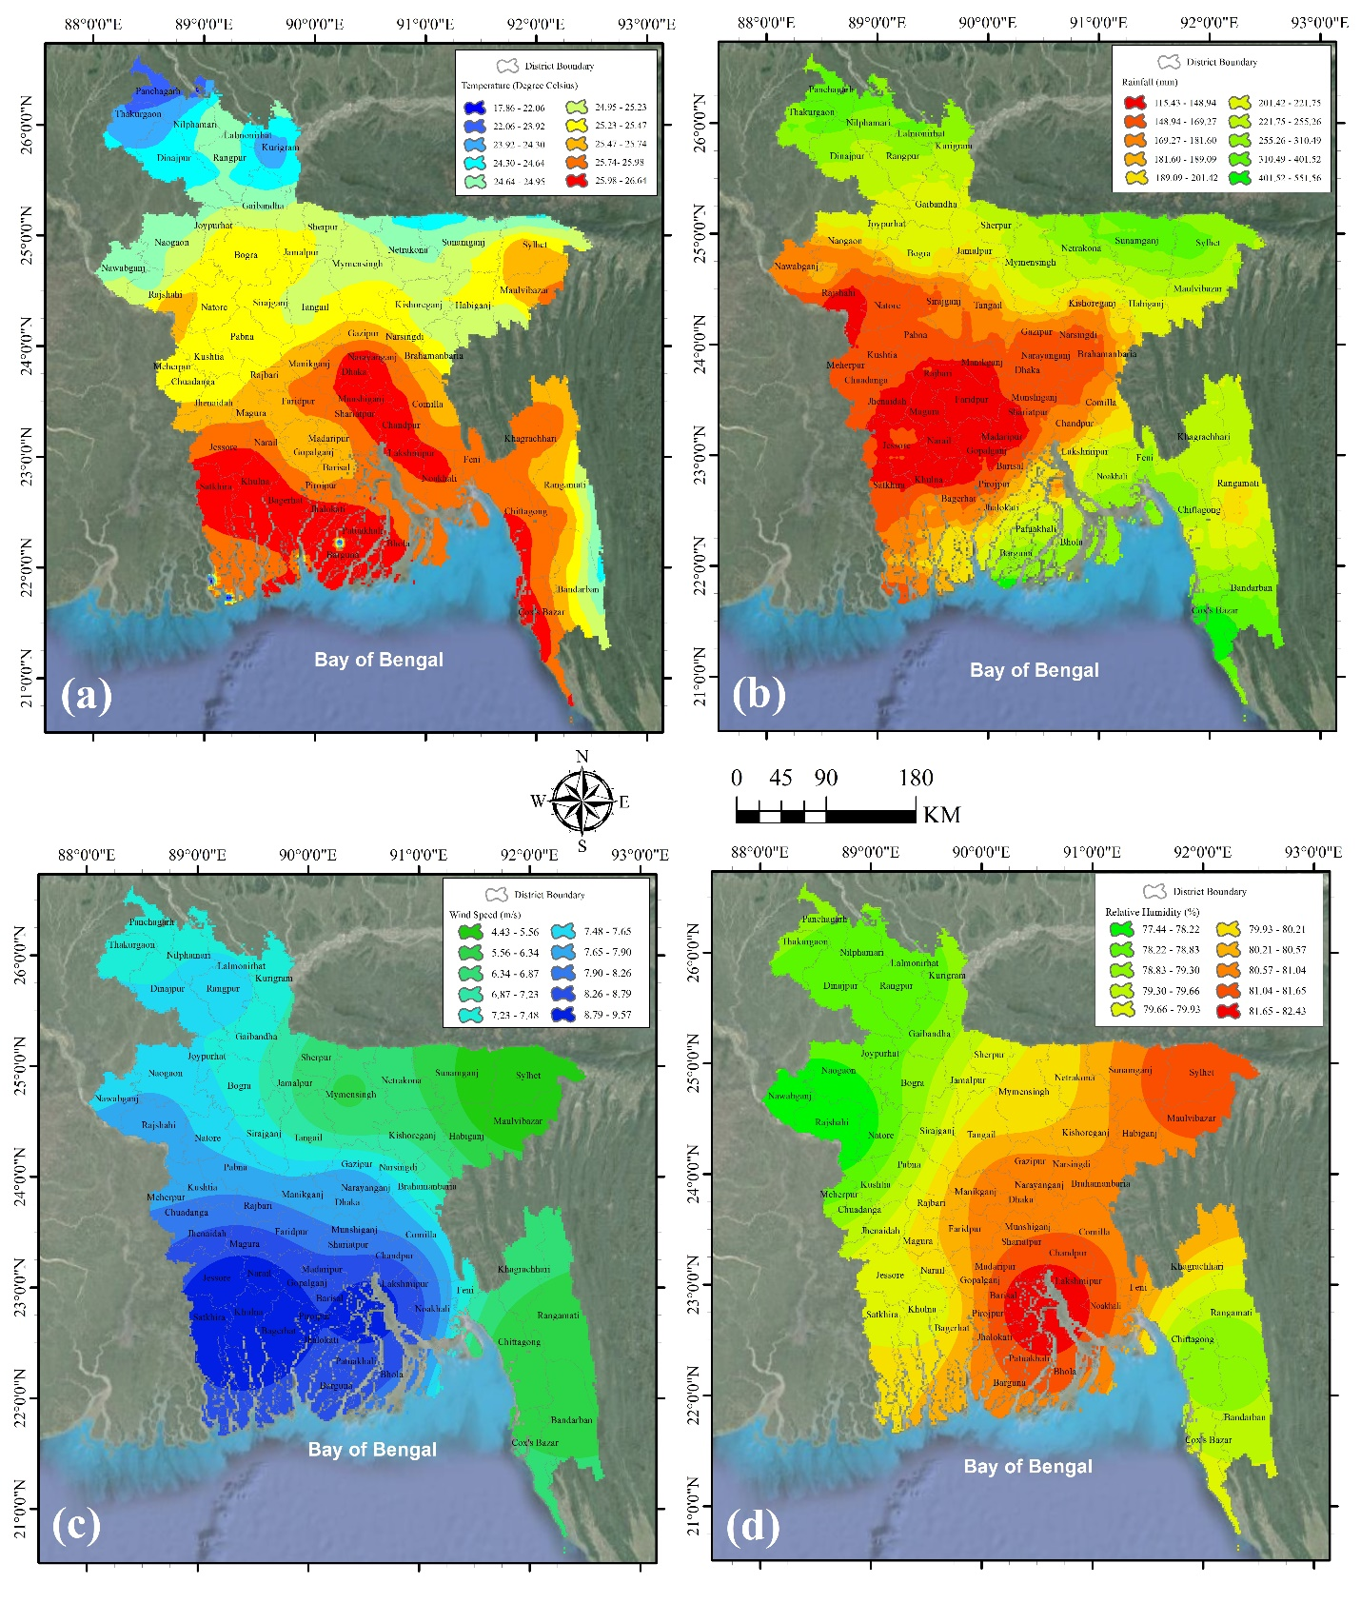

Figure 1 : Map of Bangladesh showing metrological parameters (Yearly Average of Different Meteorological variables map) (a) Air Temperature (◦C), (b) Rainfall (mm), (c) Wind (m/s) & (d) Relative Humidity (%)

**Map (a)** shows during the higher air temperature exists along central to southern parts of Bangladesh, whereas lower temperature is found along northern parts adjoining north borderline of Bangladesh and south-eastern parts bordering Myanmar. Highest and lowest temperature have been found in Bhola (26.1995 ◦C) and Lalmonirhat (21.3966 ◦C) district respectively. Possible causes can be Bhola is located adjoining to the Bay of Bengal and Lalmonirhat is located in the northern part near to the foothills of Himalyan hill ranges (29)

Rainfall in **Map (b)** shows inverse scenario with air temperature. Due to lower rainfall along central and most of the southern parts, air temperature was relatively higher. In the contrary, higher rainfall along northern Bangladesh and majority parts of Chittagong hill tracts has caused relatively lower air temperature. Higher and lower rainfalls have been noticed in Cox’s Bazar (410.0638 mm) and Narail (138.9112 mm) district respectively. Possibly monsoon weather from the south-western of the Bay of Bengal has caused higher rainfall in Cox’s Bazar district) (30).

**Map (c)** shows higher wind speed has been found across central, south-western and north-western of Bangladesh. Lower speed found across north-eastern and south-eastern parts. The highest wind speed has been found in Narail district (9.044 m/s), so due to highest wind movement Narail has experienced the lowest rainfall. Sylhet district has experienced the lowest wind speed (4.7948 m/s). As greater Sylhet division has Tripura hills on its south part, so these hills work as a barrier to higher wind speed .

**Map (d)** shows higher relative humidity along central-southern, central and north-eastern parts of Bangladesh; whereas lower amount has been noticed majorly in north-western and south-eastern parts (31).The highest and lowest relative humidity have been found in Lakshmipur (81.8055%) and Rajshahi (77.7943%) district respectively.

**Time series models**

In this study we used time series models to detect the trend of COVID-19 cases and deaths. Four mathematical time-series models: SES, ARIMA, ARIMAX and Prophet were used analysis data. The time series models were selected based on the variables where daily COVID-19 new cases data and meteorological factors were used. Using the time series models with the reported COVID-19 data, we predicted trends for the probable thirty days and presented them in the figures in result part. We also used SES model as a standard to evaluate the accuracy of other models. Previously these models were used among confirmed Covid-19 affected patients over 192 countries (32).

**SES Model (Simple Exponential Smoothing):**

The most often used model for analysing time series data is simple exponential smoothing (33). SES is not a long-term predicting tool that uses data as fluctuating around a steady mean (34–36). The R package ‘fpp2’ is use for running SES model in this study (37).

**ARIMA Model (Auto-Regressive Integrated Moving Average):**

We used the ARIMA (38), which is a statistical, data-oriented analysis that interprets a perfect model by using the structure of the data itself to forecast the trend of daily cumulative rCFR (39) ARIMA models have the advantage of being able to perform time series data oriented analysis that uses recent data to predict the future (40). For running the ARIMA model, R package ‘forecast’ used in this study (41).

The equation of this model is showed below by equation (1).

*φp(B)Фp(B5)∇DZt = θq(B)ΘQ(B5)at..................................* equation (1)

(p = Non-seasonal auto regression, d = Regular differencing, q = Order of non-seasonal MA, s = Length of season , φ = AR operator, Ф = AR variabe, ∇d = Differencing operator, = Seasonal differencing operator, Zt = Observed value at t, θ = MA operator of q, Θ = Seasonal MA parameter of Q and at = Noise component (0, σ2)).

**Prophet Model (Automatic Forecasting time-series model):**

In this study Prophet model also used to analyse time series data using the R package “prophet” to observe the 10-days CFR and compared it with rCFR (42).The Prophet model is used for irregular observations the data set and the model fits very quickly (43). The benefit is, it collects absent data also and control outliers data set (27,44). Equation 2, used for Prophet analysis (45).

*Y (t) = g(t) + s(t) + h(t) + ∈t ..................................* equation (2)

(g (t), s (t), h (t) are model factors and ∈t is used for non-periodic changes).

**Autoregressive Integrated Moving Average with Explanatory Variables (****ARIMAX)**

ARIMA models accept a direct relationship between the time-series values and attempt to exploit these straight conditions in perceptions, in arrange to extricate nearby designs, whereas removing high-frequency commotion. But in this model, the information explanatory variable (X) is added with the ARIMA model for the accurate interpretation which is called ARIMAX (p, d, q)(30)(31).

**Empirical evaluation**

All the four time series models were compared using the benchmarks in predicting the case fatality rate in this study. The benchmark allowed to measures the presence made by their counterparts (46). The SES model is the best suitable non-seasonal model for time series, permitting any error or trend element (47). In this study, we investigate and compare the execution of the considered time series models to ensure the prediction, coefficient of determination (R2), root mean square error (RMSE), and mean absolute error (MAE).

**Statistical analysis**

We have looked at how the COVID-19 cases and deaths have evolved through time series model. Through the ARIMAX model, we attempted to determine whether there is a link between COVID-19 cases and deaths with meteorological variables. The influence of the latency period of COVID-19 and time of admission were also considered into the model. The average incubation period is 5.2 days (range: 2–7 days) [<https://doi.org/10.1056/NEJMoa2002032>., <https://doi.org/10.7326/M20-0504>.], and the median time of admission was about 10 days [<https://doi.org/10.1155/2011/734690>.]. Since the coincidence of the delayed effect of latency period and time of test result/admission in the relationship between meteorological factors and cases/death [<https://doi.org/10.1136/jech.2004.020180>.], the meteorological factors delayed period of this study was set to 15 days. To perform this analysis, R software were used.

**Results**

The total positive confirmed cases of COVID-19 detected as 19, 51,831 (14%), confirmed death cases 29,129 (1.49 %), and the number of recovered case 18, 84,352 (14%) were officially reported in the Bangladesh as April 15, 2022 accordingly government dashboard (IEDCR, 2022) (Figure-2a, 2b). The five highly affected districts are Dhaka (Confirmed case-150629), Chattogram (28112), Bogura (9240), Sylhet (8837), Cumilla (8803) selected as red zoon from fifty districts (Supplementary file SF-6) (http://covid19tracker.gov.bd/). The highest number of death cases (261 death cases) in one day confirmed 5 August, 2021 for rapid spread of COVID-19 while the highest number of positive cases diagnosed as 16,230 in 28 July, 2021 (Accordingly JHU Data Base). Bangladesh is tropical-moist climate based area found seasonal diversity by precipitation, moderately environment temperature, and high relative humidity (52). In this country generally, four climatic seasons found in a year where lower temperature exists in the winter that lasts from the month December to February; higher temperature exists in the summer from the month of March to May; the rainy season exists from June to September, and the fourth number post-monsoon autumn which observed from month of October to November (53). From the observation of last 61 years (1960-2021) daily temperature data, we detected average temperature 25.20C in the month of July, minimum temperature 12.90C in the month January while maximum temperature 33.50C was observed in April of Bangladesh (Supplementary Fig-SF1). We also observed maximum precipitation 496mm in the month of July, and minimum 4 mm in the month of January.

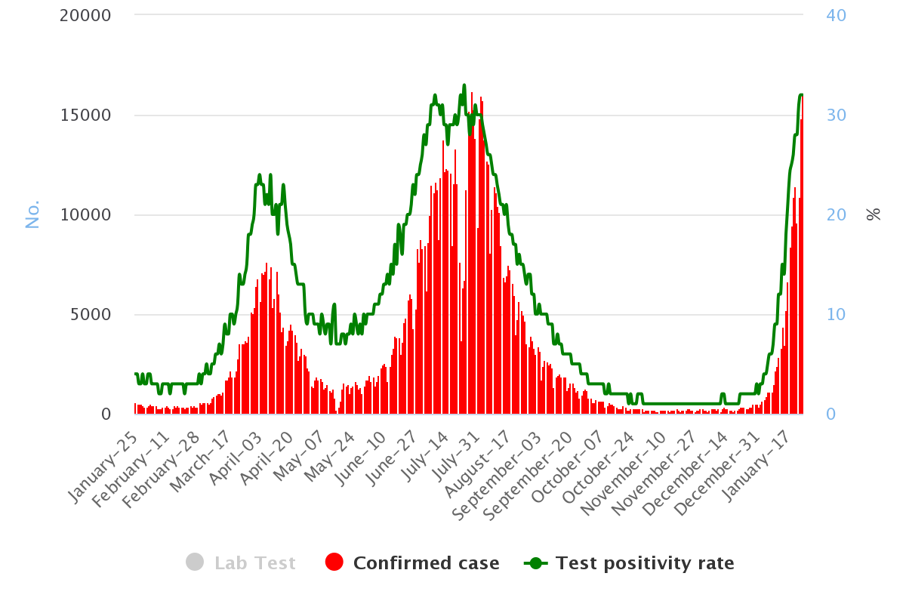

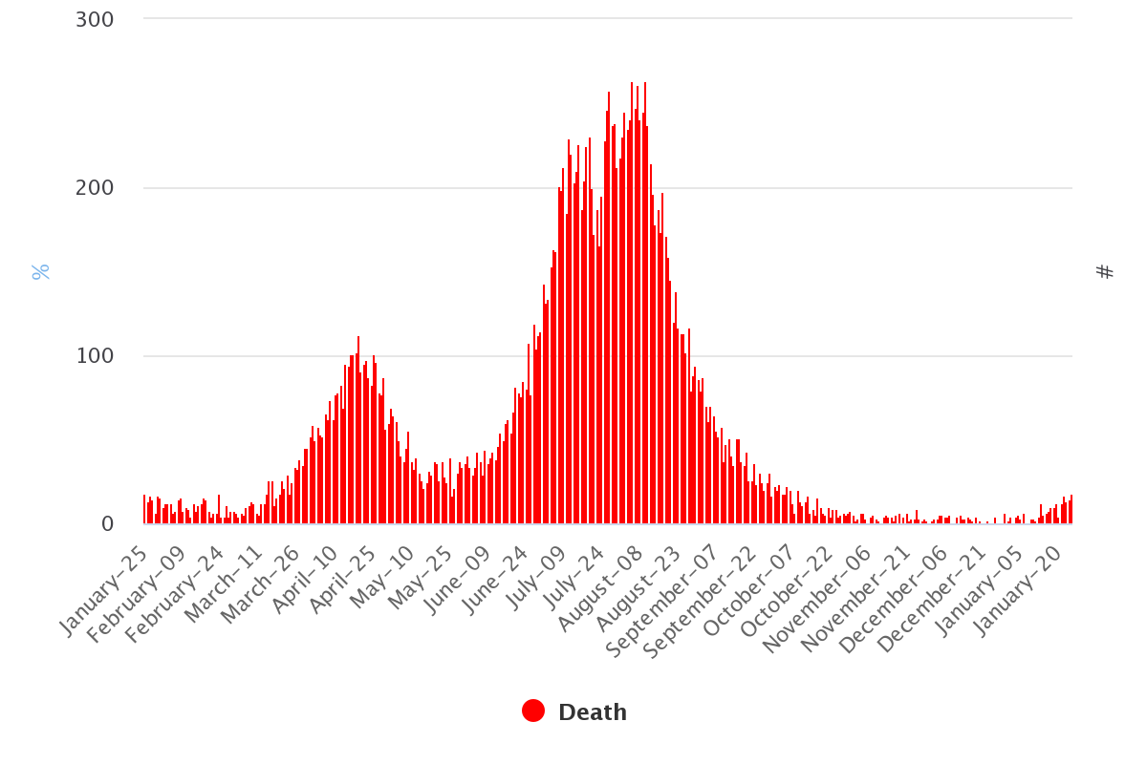

Figure-2 Total cases of COVID-19 (a) Lab test, confirmed cases (red colour), positive rate (green color) (b) Death case

We found a consistent trend between observed and predicted COVID-19 deaths in the SES model, with R2, RMSE, and MAE values of 94.97%, 719.73, and 340.16 respectively (Table 1 and Figure-4). We have identified a substantial growing trend between observed and predicted COVID-19 deaths in the ARIMAX and ARIMAX+Vaccination models, with R2, RMSE, and MAE values of 96.32% and 96.33%, 615.67 and 615.65, and 306.18 and 306.32, respectively. We also have identified a substantial growing trend between observed and predicted COVID-19 deaths in the ARIMA and Prophet models, with R2, RMSE, and MAE values of 97.38% and 74.48%, 8.31 and 25.96, and 5.57 and 20.19, respectively (Table-1).

The ARIMAX model with vaccination variable outperformed than all other models in terms of accuracy (with better R2, RMSE, and MAE values). The model has a higher coefficient of determination and smaller errors than the ARIMA, ARIMAX, Prophet and benchmark SES models. The COVID-19 deaths is predicted to rise significantly in the next 30 days, according to both models' forecasts. The forecasting of the regional daily deaths of COVID-19 for each model is shown in Figure-4.

We found a consistent trend between observed and predicted COVID-19 confirmed cases in the SES model, with R2, RMSE, and MAE values of 97.25%, 8.52, and 5.77 respectively (Table 1 and Figure-4). We have identified a substantial growing trend between observed and predicted COVID-19 cases in the ARIMAX and ARIMAX+Vaccination models, with R2, RMSE, and MAE values of 97.40% and 97.41%, 8.29 and 8.28, and 5.59 and 5.60, respectively. We also have identified a substantial growing trend between observed and predicted COVID-19 rCFR in the ARIMA and Prophet models, with R2, RMSE, and MAE values of 96.31% and 54.20%, 616.54 and 2171.11, and 303.29 and 1603.89, respectively (Table-1).

The ARIMAX model with vaccination variable outperformed than all other models in terms of accuracy (with better R2, RMSE, and MAE values). The model has a higher coefficient of determination and smaller errors than the ARIMA, ARIMAX, Prophet and benchmark SES models. The COVID-19 cases are predicted to rise significantly in the next 30 days, according to both models' forecasts. The forecasting of the regional daily cases of COVID-19 for each model is shown in Figure-4.

Table-1. The summary of SES model (Simple Exponential Smoothing), ARIMA model (Auto-Regressive Integrated Moving Average), and Prophet Model (Automatic Forecasting Time-series Model).

|  |  |  |  |  |  |  |
| --- | --- | --- | --- | --- | --- | --- |
|  | **Confirmed Cases** | | | **Confirmed Deaths** | | |
| **Method & Period** | **R2** | **RMSE** | **MAE** | **R2** | **RMSE** | **MAE** |
| ***Simple Exponential Smoothing*** | 94.97% | 719.73 | 340.16 | 97.25% | 8.52 | 5.77 |
| ***Auto-Regressive Integrated Moving Average*** | 96.31% | 616.54 | 303.29 | 97.38% | 8.31 | 5.57 |
| ***Auto-Regressive Integrated Moving Average with explanatory variables*** | 96.32% | 615.67 | 306.18 | 97.40% | 8.29 | 5.59 |
| ***Auto-Regressive Integrated Moving Average with explanatory variables + Vaccination variable*** | 96.33% | 615.65 | 306.32 | 97.41% | 8.28 | 5.60 |
| ***Automatic Forecasting time-series model*** | 54.20% | 2171.11 | 1603.89 | 74.48% | 25.96 | 20.19 |

*RMSE: Root Mean Square Error; MAE: Mean Absolute Error*

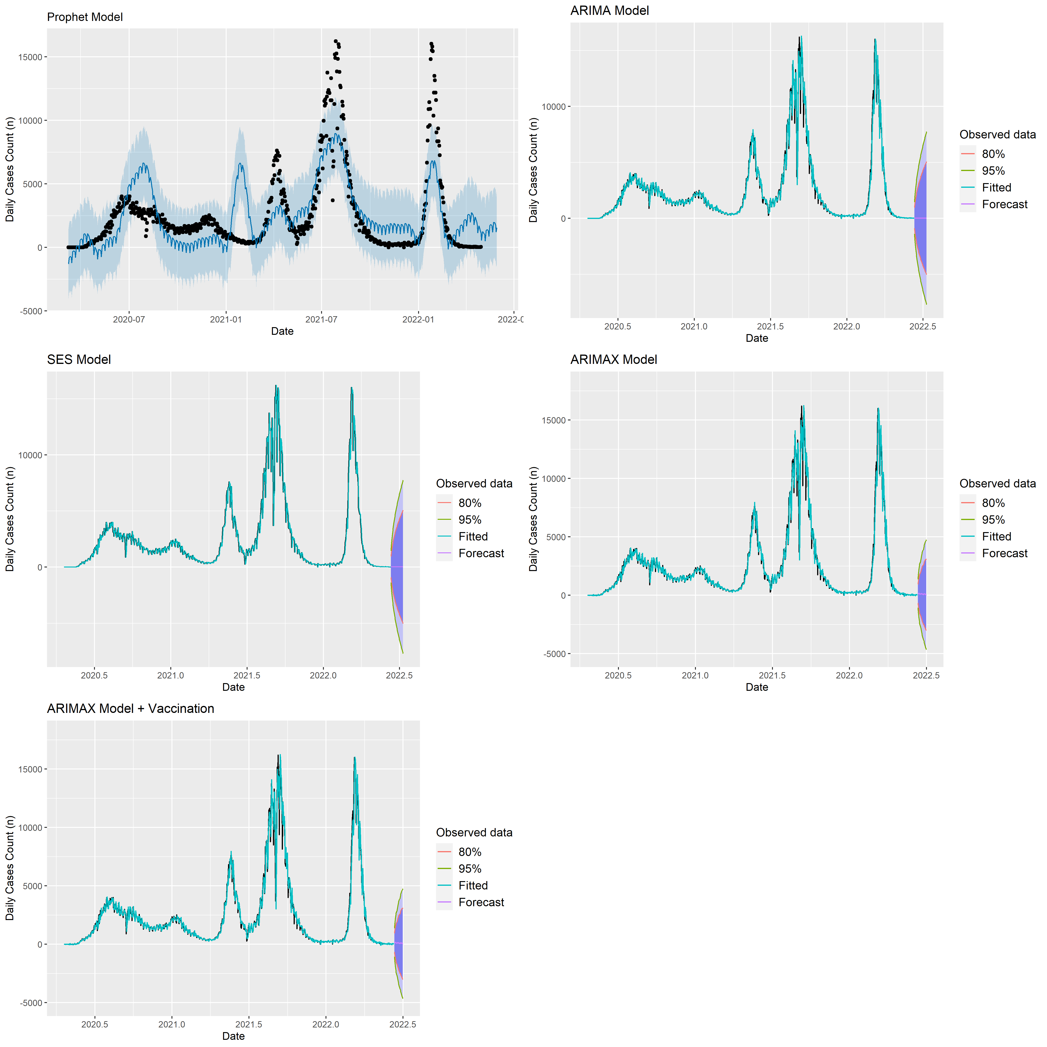

**Figure -4.** The predicting result of the regional cumulative rCFR of COVID-19 **A.** Graph shows case-fatality rate (rCFR) using SES model. **B.** Graph shows cumulative case fatality rate using an ARIMA model. **C.** Graph shows daily cumulative rCFR using an automatic forecasting time-series model (Prophet).

E:\update - Mat\CDeath.tiff

**Figure -4.** The predicting result of the regional cumulative rCFR of COVID-19 **A.** Graph shows case-fatality rate (rCFR) using SES model. **B.** Graph shows cumulative case fatality rate using an ARIMA model. **C.** Graph shows daily cumulative rCFR using an automatic forecasting time-series model (Prophet).

Table 2 describes the descriptive statistics of temperature, precipitation, dew point, relative humidity, wind speed and surface pressure of Bangladesh full period of COVID-19 cases. Accordingly, our study, the minimum temperature was identified as 14.150C that was slightly higher than previous data, while the highest temperature found 32.900C that showed lower previous studies and average temperature was 27.420C of COVID-19 cases. In the Bangladesh gradient of precipitation is identified 7mm/km from west to east accordingly previous study (54). We also found average rainfall 7.00 from beginning of pandemic where the range detected 0.00 to 105.03 mm. The average wind speed of Bangladesh of early studies found at 30 m height along the coastal belt is above 5 m/s while north eastern showed above 4.5 4.5 m/s and our results found minimum 0.55 to maximum 7.96 m/s. (54). Our study results also found average dew point, relative humidity and surface pressure 20.76, 76.89, and 100.76 respectively.

**Table-2.** Descriptive statistics of metrological parameters for confirmed cases

|  |  |  |  |  |  |  |
| --- | --- | --- | --- | --- | --- | --- |
|  | Wind Speed (m/s) | Temperature  (°C) | Dew Point  (°C) | Rainfall  (mm) | Relative Humidity  (%) | Surface Pressure  (kPa) |
| Mean | 2.28 | 25.66 | 20.76 | 7.00 | 76.89 | 100.76 |
| Median | 1.91 | 27.82 | 21.37 | 1.43 | 82.69 | 100.77 |
| Maximum | 7.96 | 32.90 | 27.46 | 105.03 | 95.31 | 101.87 |
| Minimum | 0.55 | 14.15 | 6.42 | 0.00 | 33.50 | 99.08 |
| Std. Dev. | 1.26 | 4.58 | 5.50 | 12.42 | 14.74 | 0.52 |

**Table-3.** Descriptive statistics of metrological parameters for deaths

|  |  |  |  |  |  |  |
| --- | --- | --- | --- | --- | --- | --- |
|  | Wind Speed (m/s) | Temperature  (°C) | Dew Point  (°C) | Rainfall  (mm) | Relative Humidity  (%) | Surface Pressure  (kPa) |
| Mean | 2.28 | 25.63 | 20.80 | 7.09 | 77.14 | 100.76 |
| Median | 1.91 | 27.82 | 21.58 | 1.56 | 82.88 | 100.77 |
| Maximum | 7.96 | 32.90 | 27.46 | 105.03 | 95.31 | 101.87 |
| Minimum | 0.55 | 14.15 | 6.42 | 0.00 | 33.50 | 99.08 |
| Std. Dev. | 1.26 | 4.58 | 5.52 | 12.48 | 14.64 | 0.52 |

The highest variance for COVID-19 cases in the meteorological parameters was recorded in relative humidity, with a variation of 14.74, followed by rainfall with a variation of 12.42. In contrast, the lowest variation was evident in the surface pressure at 0.52 over the country under the study period (**Table 2**). The highest variance for COVID-19 deaths in the meteorological parameters was recorded in relative humidity, with a variation of 14.64, followed by rainfall with a variation of 12.48. In contrast, the lowest variation was evident in the surface pressure at 0.52 over the country under the study period (**Table 2**).

Table 6 shows that the average temperature (-167.95, 95%CI: -244.06 to -108.17) and relative humidity (-82.74, 95%CI: -321.70 to 6.23) have a significantly negative relation with COVID-19 daily confirmed cases. We found that every 1°C fall in the average temperature and 1% fall of relative humidity from the surface will decrease COVID-19 reported cases by 168 and 83 people per day, respectively. The dew point (155.91, 95%CI: 90.89 to 502.71) have a significantly positive impact on COVID-19 daily confirmed cases. We found that every 1°C increase in the dew point in surface will increase COVID-19 reported cases by 166 people per day. These findings also similar, when we included vaccination effect in the model with meteorological variables. We found that every single dose increases in vaccination will decrease COVID-19 reported cases by 4 people per day.

Table 7 shows that the average temperature (2.66, 95%CI: 2.24 to 7.56) and relative humidity (1.25, 95%CI: 0.96 to 4.47) have a significantly positive relation with COVID-19 daily confirmed deaths. We found that every 1°C rise in the average temperature and 1% rise of relative humidity from the surface will increase COVID-19 reported deaths by 3 and 2 people per day, respectively. These findings also similar, when we included vaccination effect in the model with meteorological variables. We found that every single dose increases in vaccination will decrease COVID-19 reported deaths by 0.19 people per day.



**Table-6.** Factors associated with COVID-19 cases using ARIMAX model.

|  |  |  |  |  |  |  |
| --- | --- | --- | --- | --- | --- | --- |
|  | Confirmed Cases | | | | | |
| Variables | Without Vaccination | | | With Vaccination | | |
|  | Coef. | 95%CI | P-value | Coef. | 95%CI | P-value |
| Wind Speed | -1.25 | -70.21 to 67.71 | 0.971 | -1.23 | -70.16 to 67.70 | 0.972 |
| Average Temperature | **-167.95** | **-244.06 to -108.17** | 0.002 | -169.04 | -245.17 to 107.09 | 0.008 |
| Dew Point | 155.91 | 90.89 to 502.71 | 0.008 | 157.84 | 89.27 to 504.94 | 0.003 |
| Rainfall | **20.33** | **3.23 to 63.89** | 0.006 | 20.35 | 3.20 to 63.90 | 0.005 |
| Relative Humidity | **-82.74** | **-321.70 to -6.23** | 0.007 | **-84.31** | -323.60 to -4.99 | 0.002 |
| Surface Pressure | **-15.97** | **-174.12 to 142.18** | 0.843 | **-16.87** | **-175.19 to 141.45** | 0.835 |
| Vaccination | **-** | **-** | - | **-4.63** | **-8.65 to -2.92** | 0.004 |

**Table-7.** Factors associated with COVID-19 deaths using ARIMAX model.

|  |  |  |  |  |  |  |
| --- | --- | --- | --- | --- | --- | --- |
|  | Confirmed Cases | | | | | |
| Variables | Without Vaccination | | | With Vaccination | | |
|  | Coef. | 95%CI | P-value | Coef. | 95%CI | P-value |
| Wind Speed | 0.75 | 0.23 to 1.73 | 0.033 | 0.75 | 0.23 to 1.72 | 0.034 |
| Average Temperature | **2.66** | **2.24 to 7.56** | 0.008 | 2.61 | 2.29 to 7.51 | 0.006 |
| Dew Point | -2.22 | -7.02 to 2.58 | 0.366 | -2.23 | -7.02 to 2.57 | 0.364 |
| Rainfall | **0.15** | **-0.51 to 0.80** | 0.666 | 0.15 | -0.51 to 0.81 | 0.364 |
| Relative Humidity | **1.25** | **0.96 to 4.47** | 0.045 | **1.28** | 0.93 to 4.50 | 0.033 |
| Surface Pressure | **-0.63** | **-2.53 to 1.27** | 0.517 | **-0.59** | **-2.49 to 1.31** | 0.544 |
| Vaccination | **-** | **-** | - | **-0.19** | **-0.81 to -0.43** | 0.005 |

**Discussion:**

This is the first study, where we investigated the relationship between meteorological parameters and COVID-19 incidence in Bangladesh, considering many potential confounding variables. Our findings showed, there is a substantial modest relationship between climatic factors and daily COVID-19 cases and deaths. Overall, the results of the ARIMAX model and trend analysis data imply that daily COVID-19 cases and deaths was linked to wind speed and surface pressure. Rainfall showed a positive relationship with both COVID-19 cases and deaths.

Researchers from different parts of the world have conducted various researches to know whether metrological variables correlate with the spreading of COVID-19 infections, and some recent findings are found there is a relationship between COVID-19 infection with metrological parameters (Biktasheva 2020; Ma et al. 2020; Menebo 2020; Qi et al. 2020). Temperature, humidity, rainfall, wind speed, and dew point all played an important role on morbidity, mortality, and case-fatality rates were investigated. Moreover, some previous studies has looked at the relationship between viral diseases and weather conditions, as well as the relationship between non-infectious diseases(55). Murphy et al. (2004) observed in a research that seasonal variation related with hospitalization of patients and mortality (56). Research on the relationship between meteorological characteristics and infectious illnesses (such as avian influenza A/H5N1, SARS-CoV, and MERS-CoV) was also conducted to determine the impact of weather conditions on the transmission of previous epidemics/pandemics.

In the previous study by Ahmadi et al. (2020) explained the correlation of metrological parameters (e.g., temperature, humidity, wind speed) to the COVID-19 pandemic in Iran based on February 19 to March 22, 2020 data and observed temperature and precipitation have a positive link, but wind speed, solar radiation, and humidity have a negative effect with infected cases. Another study conducted by Shi et al. (2020) claimed that meteorological parameters correlated with the transmission of SARS-CoV-2 infection in China. Suhaimi et al. (2020) found in Kuala Lumpur, Malaysia that, meteorological variables correlate with daily cases of COVID-19. Other study results also claimed a correlation between daily COVID-19 cases and meteorological variables (6, 8). In New York City the analysis UK dataset collected from March 1, 2020, to April 12, 2020, explained the effects of metrological parameters like precipitation, temperature, humidity, and wind speed on COVID-19 cases (6). In addition, Ma et al. (2020) show how meteorological parameters play important roles in infectious diseases. On the contrary, Biktasheva (2020) explained that humidity shows a negative association with COVID-19 cases in German. Furthermore, Menebo (2020) noted that temperature and wind speed have a positive association with daily COVID-19 cases, though rainfall showed a negative connection in Norway. In Jakarta, Indonesia Tosepu et al. (2020) found that the precipitation, temperature, and humidity show a positive correlation with the COVID-19 cases. Maximum previous studies found the association of metrological factors with COVID-19 cases.

The findings of our current investigation showed that, the temperature has a detrimental influence on COVID-19 mortality, which is consistent with past research and confirms the conclusions of other investigations. Lin et al. (2006) found that the chance of an increased daily incidence of SARS-CoV (2003 pandemic) was 18 times higher on days with a lower air temperature than on days with a higher temperature (temperature greater than 24.6°C served as the reference standard) (57). Chan et al. (2011) investigated the SARS coronavirus's stability in various climatic conditions (58). They claimed high temperature with RH show a synergistic role on SARS-CoV virus inactivation, whereas low temperature and RH increase viral life time. As a result, the environmental conditions of tropical nations (e.g., Malaysia, Indonesia, and Thailand) are not suitable for the virus's long-term existence.

Based on data from 166 countries, Wu et al. (2020) found that temperature was adversely connected to daily new cases and fatalities of COVID-19 (59). According to Shi et al. (2020), the incidence of COVID-19 in China reduces as the temperature rises (60). According to Wang et al. (2020), increased temperature and RH associated with dramatically decreased COVID-19 transmission in 100 Chinese cities (61). However, different scenario were showed by Chinese scientists, Luo et al., (2020); Yao et al., (2020), who claimed that higher temperature, humidity, and UV radiation had no effect on COVID-19 incidence (62,63). The majority of the results from earlier research are consistent with our findings. The methodologies of this study were also used by a few researchers to examine the COVID-19 pandemic. Jinjarak et al. (2020) analysed the COVID-19 death rate and introduce the relationship with meteorological variables (64). Under the policy interventions, the authors separated nations. They concluded that the pandemic period to the first mortality peak in countries with early more stringent policy actions is longer than in countries that do not have such initiatives.

In our study, we found a negative relation between rainfall and COVID-19 rCFR. However, several studies established a positive association between rainfall and the transmission of influenza (13,65–67). The data suggest that influenza virus contact or short-range transmission was prevalent in tropical and subtropical regions. Droplets or aerosols formed during cough, snoring, speaking, singing, or breathing can transfer viruses into the air (65). Airborne transmission by aerosols, however, is very virulent and dominating (68). Aerosol virus survival and infectivity are affected by ambient stress temperature (69). The SARS-CoV-2 can remain alive for 3 hours in spray form (< 5 μm) but it shows higher feasibility on plastic and stainless steel, copper, carton, and glass up to 72 hours in droplet form (> 5 μm) (70). The result indicated that the viability of SARS-CoV-2 is reduced substantially due to the lower evaporation rate of the saliva contaminated droplets in high temperature. Similar to our findings, another study reported that rainfall has negative association on COVID-19 spreading in India and Pakistan (71). The precipitation rate responsible with the aggregation and washout process of aerosols in the environment and SARS-CoV-2 RNA could not have higher residence in the atmosphere and, subsequently will not active to disperse further. In addition that, a hypothetical explanation might be that persons often stay residence on drizzling days that also could decrease the spreading of COVID-19.

We also observed a positive relation of COVID-19 mortality with RH and surface pressure. Some previously conducted studies (59,61,72,73) also found same correlation of COVID-19 with RH and pressure (71). However, Shi et al. (2020) claimed different findings that there was no association between COVID-19 cases and RH (74).

The rCFR of Bangladesh had steadily increased over time, where it is sharply declining in world data.Additional factors including meteorological factors are sure to be associated. However, the growing of rCFR could be attributable to several reasons, including: the increased number of asymptomatic patients confirmed by lab testing, the introduction of dexamethasone and additional medical treatment improvements for serious patients, the acquisition of experiences by public health related occupations, improved public consciousness, protection against COVID-19 infections, important remedial uses.

**Limitation:**

The data available to the public may contain underreported numerator values (COVID-19 deaths) or denominator values (COVID-19 cases), which we have used to report rCFR. The original scenario of the country may differ for this variability of values. Day of testing, air pollution, number of cases imported, population immunity, population migrations, human mobility, and social behavior, as well as economic and cultural conditions, may confuse COVID-19 mortality, as the study did not take all of these factors into account and only looked at meteorological variables. With such limited data, a full scenario may not be present in this study. In addition, one of the main limitations of our study is that our observations are based on data about outdoor weather. However, SARS-CoV-2 transmission can be affected quite differently by indoor air conditions. These criteria should be included while evaluating the combined weather variables and the COVID-19 in Bangladesh in future studies.

**Conclusion:**

This is the first study where we used metrological data and COVID-19 rCFR for analysing correlation from Bangladesh using one year data. The daily COVID-19 confirmed cases rose until the end of July, year (2021) and then began to fall consistently. The growing number of tests and a lowering rate of rCFR for COVID-19 have been proven to be adverse. In this nation, COVID-19 rCFR was substantially linked to climatic parameters, such as rainfall, relative humidity, temperature, wind speed surface pressure, and dew point. While the wind speed and surface pressure are favourably linked to the rCFR and the others factors are adversely linked in the pre-peak cases period. All the meteorological factors in this study are favourably linked in the post-peak cases period. More reasons for reducing rCFR need to be examined in greater detail but can be explained by increasing infection among younger patients, by improving healthcare management, or by medicines that can reduce mortality and hospital stays for patients with COVID-19 and by preventing people with co-morbidities. This study reflects an increasing agreement in many national datasets and experiences with the risk variables related to CFR. Further investigations are required to understand the COVID-19 rCFR pattern and the pathogenicity of the virus at the host level. The study findings will help other researchers better understand, monitor and control the transmission of SARS-CoV-2 and policy makers can easily take decisions in the severe time of the COVID-19 diseases.

**References**

1. Islam MA, Haque MA, Rahman MA, Hossen F, Reza M, Barua A, et al. A Review on Measures to Rejuvenate Immune System: Natural Mode of Protection Against Coronavirus Infection. Front Immunol [Internet]. 2022 Mar 15;13. Available from: https://www.frontiersin.org/articles/10.3389/fimmu.2022.837290/full

2. Haider N, Yavlinsky A, Chang YM, Hasan MN, Benfield C, Osman AY, et al. The global health security index and joint external evaluation score for health preparedness are not correlated with countries’ covid-19 detection response time and mortality outcome. Epidemiol Infect. 2020;

3. Kushal SA, Amin YM, Mubassara L, Alam MM, Chakraborty PA. Managing SARS-CoV-2 outbreak challenges in psychiatric hospitals of Bangladesh. Public Heal Pract. 2020;1:100041.

4. Sakib MMH, Nishat AA, Islam MT, Raihan Uddin MA, Iqbal MS, Bin Hossen FF, et al. Computational screening of 645 antiviral peptides against the receptor-binding domain of the spike protein in SARS-CoV-2. Comput Biol Med [Internet]. 2021 Sep;136:104759. Available from: https://linkinghub.elsevier.com/retrieve/pii/S0010482521005539

5. Auler AC, Cássaro FAM, da Silva VO, Pires LF. Evidence that high temperatures and intermediate relative humidity might favor the spread of COVID-19 in tropical climate: A case study for the most affected Brazilian cities. Sci Total Environ. 2020;729.

6. Bashir MF, Ma B, Bilal, Komal B, Bashir MA, Tan D, et al. Correlation between climate indicators and COVID-19 pandemic in New York, USA. Sci Total Environ. 2020;728.

7. Hossain M, Saiha Huq T, Rahman A, Aminul Islam M, Naushin Tabassum S, Nadim Hasan K, et al. Novel mutations identified from whole-genome sequencing of SARS-CoV-2 isolated from Noakhali, Bangladesh. 2021;

8. Ling S. Particulate matter air pollution exposure: role in the development and exacerbation of chronic obstructive pulmonary disease. Int J Chron Obstruct Pulmon Dis [Internet]. 2009 Jun;233. Available from: http://www.dovepress.com/particulate-matter-air-pollution-exposure-role-in-the-development-and--peer-reviewed-article-COPD

9. Velavan TP, Meyer CG. The COVID-19 epidemic. Trop Med Int Heal. 2020;25(3):278–80.

10. Riddell S, Goldie S, Hill A, Eagles D, Drew TW. The effect of temperature on persistence of SARS-CoV-2 on common surfaces. Virol J. 2020 Oct;17(1).

11. Park J, Son W, Ryu Y, Choi SB, Kwon O, Ahn I. Effects of temperature, humidity, and diurnal temperature range on influenza incidence in a temperate region. Influenza Other Respi Viruses. 2020 Jan;14(1):11–8.

12. van Doremalen N, Bushmaker T, Munster VJ. Stability of middle east respiratory syndrome coronavirus (MERS-CoV) under different environmental conditions. Eurosurveillance. 2013 Sep;18(38):20590.

13. Bi P, Wang J, Hiller JE. Weather: driving force behind the transmission of severe acute respiratory syndrome in China? Intern Med J. 2007 Aug;37(8):550–4.

14. Tan J, Mu L, Huang J, Yu S, Chen B, Yin J. An initial investigation of the association between the SARS outbreak and weather: with the view of the environmental temperature and its variation. J Epidemiol Community Health. 2005 Mar;59(3):186–92.

15. Lowen AC, Mubareka S, Steel J, Palese P. Influenza Virus Transmission Is Dependent on Relative Humidity and Temperature. PLOS Pathog. 2007 Oct;3(10):e151.

16. Altamimi A, Ahmed AE. Climate factors and incidence of Middle East respiratory syndrome coronavirus. J Infect Public Health. 2020 May;13(5):704–8.

17. Jakariya M, Ahmed F, Islam MA, Ahmed T, Marzan A Al, Hossain M, et al. Wastewater based surveillance system to detect SARS-CoV-2 genetic material for countries with on-site sanitation facilities: an experience from Bangladesh. medRxiv. 2021;8852000:2021.07.30.21261347.

18. Ahmed F, Islam MA, Kumar M, Hossain M, Bhattacharya P, Islam MT, et al. First detection of SARS-CoV-2 genetic material in the vicinity of COVID-19 isolation Centre in Bangladesh: Variation along the sewer network. Sci Total Environ. 2021 Jul;776:145724.

19. DHS S&T Launches Indoor Predictive Modeling Tool for Coronavirus Stability. 2020.

20. Nasirpour MH, Sharifi A, Ahmadi M, Jafarzadeh Ghoushchi S. Revealing the relationship between solar activity and COVID-19 and forecasting of possible future viruses using multi-step autoregression (MSAR). Environ Sci Pollut Res. 2021 Jul;28(28):38074–84.

21. Ahmadi M, Sharifi A, Dorosti S, Jafarzadeh Ghoushchi S, Ghanbari N. Investigation of effective climatology parameters on COVID-19 outbreak in Iran. Sci Total Environ. 2020 Aug;729:138705.

22. Bashir MF, Ma B, Bilal, Komal B, Bashir MA, Tan D, et al. Correlation between climate indicators and COVID-19 pandemic in New York, USA. Sci Total Environ. 2020 Aug;728:138835.

23. Tan L, Schultz DM. How Is COVID-19 Affected by Weather? Metaregression of 158 Studies and Recommendations for Best Practices in Future Research. Weather Clim Soc. 2022 Jan;14(1):237–55.

24. Islam et al.;2021. Sex-specific epidemiological and clinical characteristics of COVID-19 patients in the southeast region of Bangladesh 2021.MedRxivhttps://doi.org/10.1101/2021.07.05.21259933.

25. Prata DN, Rodrigues W, Bermejo PH. Temperature significantly changes COVID-19 transmission in (sub)tropical cities of Brazil. Sci Total Environ. 2020 Aug;729:138862.

26. Coronavirus disease (COVID-2019) Bangladesh situation reports.

27. Hasan MN, Haider N, Stigler FL, Khan RA, McCoy D, Zumla A, et al. The Global Case-Fatality Rate of COVID-19 Has Been Declining Since May 2020. Am J Trop Med Hyg. 2021 Apr;

28. NASA. POWER | Data Access Viewer. 2022.

29. Rimi RH, Haustein K, Allen MR, Barbour EJ. Risks of Pre-Monsoon Extreme Rainfall Events of Bangladesh: Is Anthropogenic Climate Change Playing a Role? Bull Am Meteorol Soc [Internet]. 2019 Jan;100(1):S61–5. Available from: https://journals.ametsoc.org/view/journals/bams/100/1/bams-d-18-0152.1.xml

30. Rahman A, Haque Jiban MJ, Munna SA. Regional Variation of Temperature and Rainfall in Bangladesh: Estimation of Trend. Open J Stat [Internet]. 2015;05(07):652–7. Available from: http://www.scirp.org/journal/doi.aspx?DOI=10.4236/ojs.2015.57066

31. Mortuza MR, Moges E, Demissie Y, Li H-Y. Historical and future drought in Bangladesh using copula-based bivariate regional frequency analysis. Theor Appl Climatol [Internet]. 2019 Feb 19;135(3–4):855–71. Available from: http://link.springer.com/10.1007/s00704-018-2407-7

32. Chyon FA, Suman MNH, Fahim MRI, Ahmmed MS. Time series analysis and predicting COVID-19 affected patients by ARIMA model using machine learning. J Virol Methods [Internet]. 2022 Mar;301:114433. Available from: https://linkinghub.elsevier.com/retrieve/pii/S0166093421003724

33. de Livera AM, Hyndman RJ, Snyder RD. Forecasting time series with complex seasonal patterns using exponential smoothing. J Am Stat Assoc. 2011 Dec;106(496):1513–27.

34. Chaurasia V, Pal S. Application of machine learning time series analysis for prediction COVID-19 pandemic. Res Biomed Eng. 2020 Oct;1–13.

35. Tseng YJ, Shih YL. Developing epidemic forecasting models to assist disease surveillance for influenza with electronic health records. Int J Comput Appl. 2020 Aug;42(6):616–21.

36. Ali M, Khan DM, Aamir M, Khalil U, Khan Z. Forecasting COVID-19 in Pakistan. Zeng Q, editor. PLoS One. 2020 Nov;15(11 November):e0242762.

37. Data T, All D, Athanasopoulos G, Ggally S, Utf- E, Gpl- L, et al. Package ‘fpp2.’ 2020;1–23.

38. Dyer O. Covid-19: Remdesivir has little or no impact on survival, WHO trial shows. BMJ. 2020 Oct;371:m4057.

39. Adhikari R, Agrawal RK. An Introductory Study on Time Series Modeling and Forecasting. 2013 Feb;

40. Papastefanopoulos V, Linardatos P, Kotsiantis S. COVID-19: A Comparison of Time Series Methods to Forecast Percentage of Active Cases per Population. Appl Sci 2020, Vol 10, Page 3880. 2020 Jun;10(11):3880.

41. Hyndman R, … GA-O https://cran. r, 2020 U. Package “forecast” Title Forecasting Functions for Time Series and Linear Models Description Methods and tools for displaying and analysing univariate time series forecasts including exponential smoothing via state space models and automatic ARIMA modelli. sunsite.icm.edu.pl. 2020.

42. Letham B. Package “prophet” Title Automatic Forecasting Procedure. 2019;1–16.

43. Kumar N, Susan S. COVID-19 Pandemic Prediction using Time Series Forecasting Models. In: 2020 11th International Conference on Computing, Communication and Networking Technologies, ICCCNT 2020. Institute of Electrical and Electronics Engineers Inc.; 2020.

44. Samal KKR, Babu KS, Das SK, Acharaya A. Time series based air pollution forecasting using SARIMA and prophet model. In: ACM International Conference Proceeding Series. New York, New York, USA: Association for Computing Machinery; 2019. p. 80–5.

45. Facebook. Automatic forecasting procedure.

46. Kourentzes N, Petropoulos F. Forecasting with multivariate temporal aggregation: The case of promotional modelling. Int J Prod Econ. 2016 Nov;181:145–53.

47. Haider N, Hasan MN, Khan RA, McCoy D, Ntoumi F, Dar O, et al. The Global case-fatality rate of COVID-19 has been declining disproportionately between top vaccinated countries and the rest of the world. medRxiv. 2022 Jan;2022.01.19.22269493.

48. Cribari-Neto F, Zeileis A. Beta regression in R. J Stat Softw. 2010 Apr;34(2):1–24.

49. Ferrari SLP, Cribari-Neto F. Beta regression for modelling rates and proportions. J Appl Stat. 2004 Aug;31(7):799–815.

50. Parang K, Wiebe L, Knaus E. Novel Approaches for Designing 5-O-Ester Prodrugs of 3-Azido-2,3-dideoxythymidine (AZT). Curr Med Chem. 2012;7(10):995–1039.

51. Pohlert. Package “trend.” Package “trend.” 2020. p. 1–18.

52. Kamruzzaman M, Mandal T, Rahman ATMS, Abdul Khalek M, Alam GMM, Rahman MS. Climate Modeling, Drought Risk Assessment and Adaptation Strategies in the Western Part of Bangladesh. In 2021. p. 21–54. Available from: https://link.springer.com/10.1007/978-3-030-77259-8_2

53. Shahid S, Khairulmaini OS. Spatio-temporal variability of rainfall over Bangladesh during the time period 1969-2003. Asia-Pacific J Atmos Sci. 2009;43(5):375–89.

54. Islam SMS, Islam KMA, Mullick MRA. Drought hot spot analysis using local indicators of spatial autocorrelation: An experience from Bangladesh. Environ Challenges [Internet]. 2022 Jan;6:100410. Available from: https://linkinghub.elsevier.com/retrieve/pii/S266701002100384X

55. Rahman K, Vandoni M, Cheval B, Asaduzzaman M, Hasan MN, Rahman ST, et al. Exploring Two Pandemics in Academic Arena: Physical Activity and Sedentary Behaviors Profile of University Students in Bangladesh. Eur J Investig Heal Psychol Educ 2021, Vol 11, Pages 358-371. 2021 Apr;11(2):358–71.

56. Murphy NF, Stewart S, MacIntyre K, Capewell S, McMurray JJV. Seasonal variation in morbidity and mortality related to atrial fibrillation. Int J Cardiol. 2004 Nov;97(2):283–8.

57. LIN K, YEE-TAK FONG D, ZHU B, KARLBERG J. Environmental factors on the SARS epidemic: air temperature, passage of time and multiplicative effect of hospital infection. Epidemiol Infect. 2006 Apr;134(2):223–30.

58. Sekine K, Hodgkin ME. Effect of child marriage on girls’ school dropout in Nepal: Analysis of data from the Multiple Indicator Cluster Survey 2014. PLoS One. 2017;12(7).

59. Wu Y, Jing W, Liu J, Ma Q, Yuan J, Wang Y, et al. Effects of temperature and humidity on the daily new cases and new deaths of COVID-19 in 166 countries. Sci Total Environ. 2020 Aug;729.

60. Shi P, Dong Y, Yan H, Zhao C, Li X, Liu W, et al. Impact of temperature on the dynamics of the COVID-19 outbreak in China. Sci Total Environ. 2020 Aug;728.

61. Wang J, Tang K, Feng K, Lin X, Lv W, Chen K, et al. Impact of Temperature and Relative Humidity on the Transmission of COVID-19: A Modeling Study in China and the United States. SSRN Electron J. 2020 Mar;

62. Yao Y, Pan J, Liu Z, Meng X, Wang W, Kan H, et al. No association of COVID-19 transmission with temperature or UV radiation in Chinese cities. Eur Respir J. 2020 May;55(5).

63. Luo W, Majumder MS, Liu D, Poirier C, Mandl KD, Lipsitch M, et al. The role of absolute humidity on transmission rates of the COVID-19 outbreak. medRxiv. 2020;

64. Jinjarak Y, Ahmed R, Nair-Desai S, Xin W, Aizenman J. Accounting for Global COVID-19 Diffusion Patterns, January–April 2020. Econ Disasters Clim Chang. 2020 Oct;4(3):515–59.

65. Mahamat A, Dussart P, Bouix A, Carvalho L, Eltges F, Matheus S, Miller M.A, Quenel P VC. Climatic drivers of seasonal influenza epidemics in French Guiana. J Infect. 2013;67(2):141–7.

66. Lopez D, Gunasekaran M, Murugan BS, Kaur H, Abbas KM. Spatial big data analytics of influenza epidemic in Vellore, India. In: 2014 IEEE International Conference on Big Data (Big Data). IEEE; 2014. p. 19–24.

67. Gomez-Barroso D, León-Gómez I, Delgado-Sanz C, Larrauri A. Climatic Factors and Influenza Transmission, Spain, 2010–2015. Int J Environ Res Public Health. 2017 Nov;14(12):1469.

68. Zhang Z, Xue T, Jin X. Effects of meteorological conditions and air pollution on COVID-19 transmission: Evidence from 219 Chinese cities. Sci Total Environ. 2020 Nov;741:140244.

69. Jayaweera M, Perera H, Gunawardana B, Manatunge J. Transmission of COVID-19 virus by droplets and aerosols: A critical review on the unresolved dichotomy. Environ Res. 2020 Sep;188:109819.

70. van Doremalen N, Bushmaker T, Morris DH, Holbrook MG, Gamble A, Williamson BN, et al. Aerosol and Surface Stability of SARS-CoV-2 as Compared with SARS-CoV-1. N Engl J Med. 2020 Apr;382(16):1564–7.

71. Hossain MS, Ahmed S, Uddin MJ. Impact of weather on COVID-19 transmission in south Asian countries: An application of the ARIMAX model. Sci Total Environ. 2021 Mar;761:143315.

72. Gupta S, Raghuwanshi GS, Chanda A. Effect of weather on COVID-19 spread in the US: A prediction model for India in 2020. Sci Total Environ. 2020 Aug;728.

73. Ma Y, Zhao Y, Liu J, He X, Wang B, Fu S, et al. Effects of temperature variation and humidity on the death of COVID-19 in Wuhan, China. Sci Total Environ. 2020 Jul;724.

74. Shi P, Dong Y, 3# Y, 1# L, Zhao C, Liu W, et al. The impact of temperature and absolute humidity on the coronavirus disease 2019 (COVID-19) outbreak - evidence from China. medRxiv. 2020 Mar;2020.03.22.20038919.